TN SKILL PROJECT | REQUIREMENT ANALYSIS PHASE
Auto Ticket Classification using Flow Designer
Technology Track

1. PURPOSE
This document lists the technologies chosen to build the Auto Ticket Classification solution and explains the role of each one. The choice follows the functional and non-functional requirements, and the goal is to automate triage using tools that are already part of the service desk platform.

2. TECHNOLOGY TRACK OVERVIEW
Layer | Technology / Component | Role in the project
Platform | Enterprise ITSM platform (cloud, low-code) | Hosts the service desk, ticket tables, users, groups and the automation engine.
Automation | Flow Designer | Runs the classification and routing logic with no manual triage.
Rule logic | Keyword and decision rule table, flow conditions | Stores keyword to category, priority and group mapping that admins can edit.
Data | Incident, Request Item, Assignment Group and SLA Definition tables | Hold the ticket data and reference data read and updated by the flow.
Notification | Platform notification engine (email and in-app) | Alerts the assigned resolver group as soon as the ticket is routed.
SLA | Platform SLA engine | Attaches response and resolution timers based on priority.
Reporting | Dashboards and reports | Show routing accuracy, re-assignment rate and SLA compliance to the IT Manager.
Testing | Development instance, flow test run, sample incident dataset | Verify every rule and route before it goes live.

3. TECHNOLOGY ARCHITECTURE
The technology track has four layers. Tickets enter through the input layer, Flow Designer processes them, the data layer supplies rules and reference data, and the output layer delivers the routed ticket, alerts and reports.
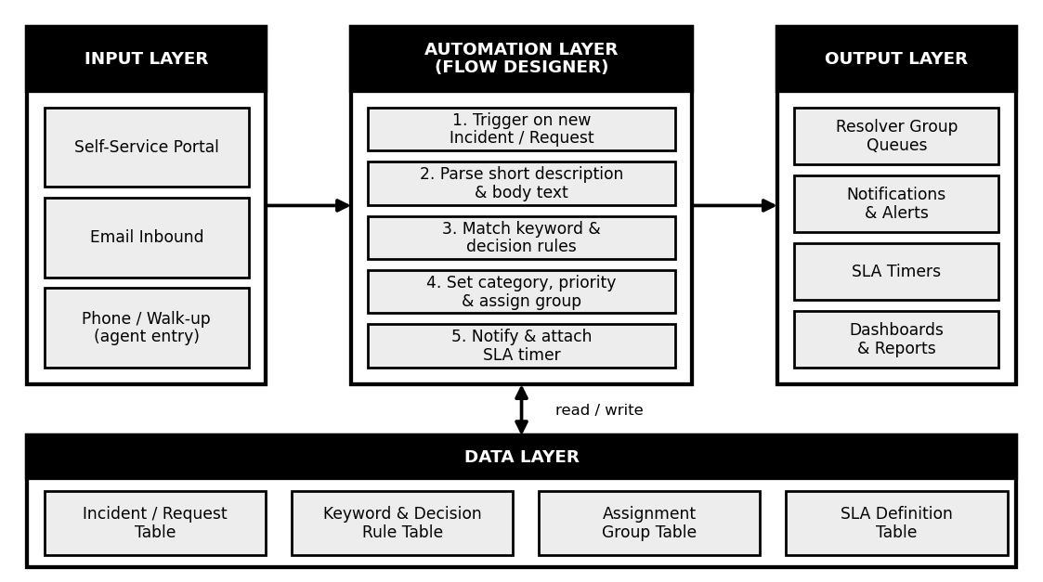
Figure 1: Layered technology architecture

4. FLOW DESIGNER COMPONENTS USED
Flow Designer Component | Use in this project
Trigger | Record created on the Incident and Request Item tables starts the flow for every new ticket.
Conditions and logic | If / else branches check keyword matches and decide the category, priority and group.
Look up record | Reads the matching row from the keyword and decision rule table.
Update record | Writes Category, Subcategory, Urgency, Priority and Assignment Group to the ticket.
Notification action | Sends an alert to the assigned resolver group.
Subflow | A reusable classification subflow that can serve both Incident and Request flows.
Error handling | Sends any failed or unmatched ticket to the default review queue for a Tier-1 Agent.
Execution history | Shows every flow run, so a wrong routing can be traced and fixed.

5. WHY THIS TECHNOLOGY
Requirement | How the technology meets it
Instant classification (under 10 seconds) | Event-driven trigger runs the moment the ticket is created.
Easy rule changes without code | Rules live in a table and flows are built with a visual, low-code designer.
Consistent decisions | The same rule table drives every ticket, so identical issues get identical results.
No lost tickets | Error handling and the review queue catch anything the rules cannot match.
Fast delivery | Uses features already inside the platform, so no new tools or integrations are needed.

6. ENVIRONMENTS AND TOOLS
Environment / Tool | Purpose
Development instance | Build and change the flow, rule table and notifications safely.
Test instance | Run the standard incident dataset and check accuracy and speed.
Production instance | Live service desk where the tested flow is activated.
Change packaging | Move the flow and rule table from development to test and production as one controlled package.
Sample dataset | Incidents covering VPN, password, hardware, database and security issues, plus vague ones such as "System error".

7. SKILLS REQUIRED
- Flow Designer: building triggers, conditions, actions and subflows.
- ITSM knowledge: understanding incidents, requests, categories, priorities and SLAs.
- Rule design: writing clear keyword and decision rules that do not overlap.
- Testing: preparing sample data and checking accuracy, speed and fallback behaviour.

8. TECHNOLOGY RISKS AND MITIGATION
Risk | Impact | Mitigation
Vague ticket text | No keyword match | Review queue for Tier-1 Agents; guided fields on the portal.
Rules become outdated | Accuracy drops over time | Monthly rule review using the manager report.
Overlapping keywords | Wrong group assigned | Rule order and priority; test each rule with sample data.
Flow failure at peak load | Tickets left unassigned | Error handling, monitoring and execution history checks.

9. CONCLUSION
A low-code, event-driven technology track built on Flow Designer and the existing ITSM platform is enough to meet every requirement. It removes manual triage, keeps rules easy to maintain, and can be delivered quickly without extra tools or integrations.

